Bioretention Technical Design Guidelines 2026 update
Water by Design has recently produced a draft update to our Bioretention Technical Design Guidelines and are seeking feedback on it.
This update incorporates more than 10 years of additional bioretention design knowledge into an already widely used document. Some key areas where changes have been made to the document include:
- Increase of the minimum filter media depth from 400 mm to 600 mm. Removal of any additional depth requirements for trees (Section 2.4).
- New section on functional design (Section 3.1).
- Enhanced guidance on how to configure large bioretention systems (Section 3.4.3.1).
- New guidance and clarification regarding collocation with detention basins (Section 3.4.9) and flood immunity requirements (Section 3.4.10).
- Further guidance on the use of energy dissipation and alignment of sediment forebays (Section 3.5.3.3).
- Reduced requirements for underdrainage cleanout points (Section 3.6.1.1).
- Alterations to pit and riser configurations for saturated zone systems (Section 3.6.1.4).
- Guidance on the use of temporary upstands during plant establishment (Section 3.6.1.5).
- Expanded vegetation design section with much greater focus on planting to create resilient low-maintenance ecosystems. The use of trees is now the default in all bioretention unless there is an overriding reason not to include them (Section 3.7).
A full list of changes is available in Section 1.1 of the guideline.

How to provide feedback
To provide feedback, please complete the template below and email a copy to jack.m@hlw.org.au by Friday 1 May 2026.
If you would like to know more or have any questions, please contact jack.m@hlw.org.au.

Feedback form: Bioretention Technical Design Guidelines
Section /  Page number  (if relevant) | Issue | Proposed change
Section 2.4 | Addition of a fifth drainage profile. Changes to the naming convention for several existing drainage profiles  Comment: Changes generally supported, no further comment. | N/A
Section 2.4 | Increase of the minimum filter media depth from 400 mm to 600 mm. Removal of any additional depth requirements for trees  Comment: The need to increase the minimum depth of filter media to 600mm in order to support the new default multi-story planting is understood and supported. Notwithstanding, it is noted that this may be challenging in depth constrained environments such as flat sites and coastal areas with high groundwater, tidal incursion or storm surge. Applying this in the field may not always be practical. | It is suggested that the change in the minimum depth of filter media to 600mm is retained but that some commentary about exceptions be provided to enable a performance-based approach as the exception rather than the rule.
Section 2.6 | New section on how to design bioretention for different geographic and climatic regions.  Comment: Changes generally supported, no further comment. | N/A
Section 3.1 | New section on functional design  Comment: These additions are considered a very valuable addition to the guidelines and are supported. Comments include the following:  - The changes include the comment that, ‘It is critical that for bioretention systems delivered through the development assessment process, conceptual and functional design (at a minimum) are delivered for the planning stage of development assessment.’ While this is correct, it would be valuable to the reader to also explain why it is important and the consequences of not following the advice i.e.: approvals which cannot be implemented; the need for changes in development approvals; projects/application delays: increased costs for the developer; non-compliance with water quality objectives.  - Similarly, reflecting the Queensland planning process in Figure 15. Bioretention design process, would help development assessment staff understand the design process as it relates to the planning process.  - The guidelines suggest that constrained sites can be managed by, ‘judicious use of steeper batters or walls, ensuring that a safe and aesthetic outcome is still achieved.’ It is suggested that this section should refer to Section 3.4.5.5 for further advice on use of walls. | 1. Provide explanation as to why providing functional or detailed design at the planning stage is important and the consequences of not following the advice.  2. It is also recommended that Figure 15. Bioretention design process, be updated to show the stages of the Queensland planning process for both reconfiguration of a lot (RoL) and material change of use (MCU) applications - a simple but valuable addition.  3. It is recommended that this section should refer to Section 3.4.5.5 for further advice on use of walls.
Section 3.3.2.1 | Updated guidance on filter media specifications  Comment: Stormwater Queensland does support the advice that the default specification should be the Adoption Guidelines for Stormwater Biofiltration Systems (CRCWSC). Specifically, it is noted that:  - There is nothing, to the best of our knowledge, which is controversial in the Specifications for Bioretention Filter Media (Water by Design). This is especially the case as the specification is supported by the scientific literature review.  - The Specifications for Bioretention Filter Media (Water by Design) are based upon a significantly greater review of scientific literature compared to Adoption Guidelines for Stormwater Biofiltration Systems (CRCWSC). Compare the list of references of each specification:  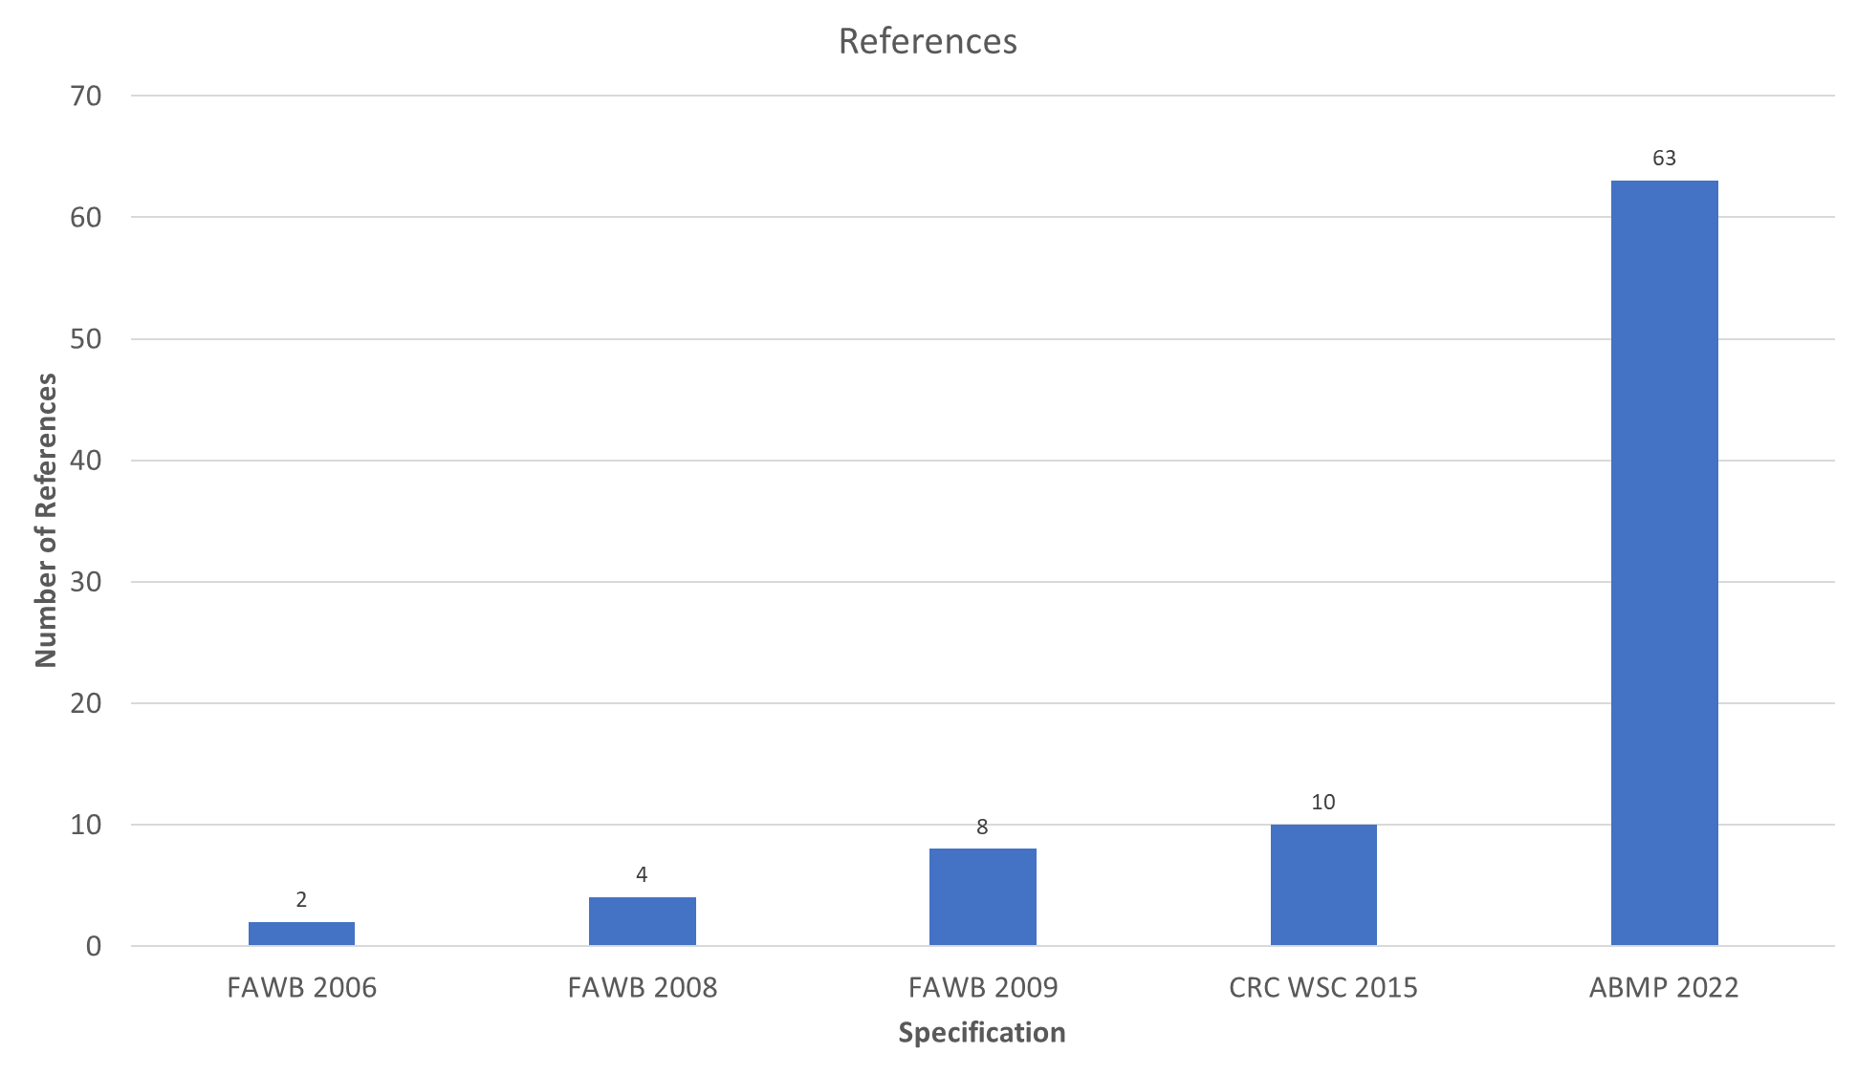  - Also consider the original FAWB specifications are supported by only a few scientific references and are actually based on a golf coarse green specification which was not intended for water quality treatment and plant survival and assumed high/frequent fertilizer application and daily irrigation. If anything, the CRCWSC is the more controversial specification from a scientific standpoint. That it has been adopted more broadly does mean it more accurately meets the needs of bioretention systems.  - The Specifications for Bioretention Filter Media (Water by Design) were originally going to include a higher level of organics in the filter media and as concession, it was decided to leave those organics out of the media and retain them in a separate compost layer.  - If a further concession was warranted and justified (we do not believe it is), the bioretention TDG could simply make this compost layer optional.  - To publish a specification and not recommend it is very confusing to the industry. One step forward, two steps back in terms of progression of best practice. It effectively sterilises the document and ensures that no systems will be constructed using this specification only enforcing the logic for not adopting it i.e. that it has not been widely implemented.  - Given the strong scientific justification behind Specifications for Bioretention Filter Media (Water by Design), the logic that it is ‘jumping the gun’ does not stand up to scrutiny. The same scientific rigour does not exist for either the FAWB or CRC specs. | It is recommended that the guidelines refer to the Specifications for Bioretention Filter Media (Water by Design) as the default filter media specification.
Section 3.3.3.4 | Rewording to clarify the section relating to setting the maximum water level  Comment: Changes generally supported, no further comment. | N/A
Section 3.3.4 | New guidance on how to prepare the base of bioretention systems where infiltration is a key goal  Comment: Changes generally supported, no further comment. | N/A
Section 3.3.5 | Refinement of guidance on acceptable and unacceptable liner types  Comment: Changes generally supported, no further comment. | N/A
Section 3.4.3.1 | Enhanced guidance on how to configure large bioretention systems  Comment: Changes generally supported, no further comment. | N/A
Section 3.4.5.3 | Clarified that finished surface levels for batters/embankments must allow for topsoil  Comment: Changes generally supported, no further comment. | N/A
Section 3.4.5.5 and Section 3.4.5.6 | Clarification of guidance regarding walls (above ground) and the interface with in-situ soils  Comments: Changes are generally supported.  The recommendation to plant the vegetated strip between walls with trees may not achieve the desired outcome of screening the low walls. A combination of high groundcovers and shrubs may be a more responsive design solution.  The recommendation for the vegetated strip to be 3m wide is supported for larger basins but for smaller basins like the one shown in Figure 25, where the overall available width is already around ~6m and the site is space constrained, this may be impractical. An alternative may be to:  - reduce the width of the planting strip as little as possible but even potentially down to 1m  - plant with groundcovers and small shrubs which will cover the walls at mature height and survive in the narrower strip of soil  - use of structural soil vault systems, otherwise known as soil cells, in the planting strip to support plant growth and improve plant growth/longevity.  While the advice about splitting walls with a vegetated strip is strongly supported it would still greatly benefit from a diagram. | 1. Reconsider the planting advice and amend as appropriate.  2. Provide a separate approach for splitting walls in large and small basins including advice about to improve outcomes in narrow planting strips between retaining walls.  3. Provide a diagram showing the split wall design approach. Sperate diagrams for small and large basins is recommended.
Section 3.4.6 | Enhanced guidance on maintenance access  Comments: Changes are generally supported.  The comments could be enhanced by specifically noting that any retaining walls located adjacent to access paths should be designed so as not to inhibit machinery access (refer to Figure 59), i.e. it would be good to explain why this figure represents an example of poor design. | It is recommended that advice be provided that any retaining walls located adjacent to access paths should be designed so as not to inhibit machinery access (refer to Figure 59).
Section 3.1.2 and Section 3.4.8 | Additional guidance on the design of streetscape bioretention systems  Comment: The changes in this section are supported but would greatly benefit from a series of diagrams. See adjacent examples. | It is suggested that diagrams similar to those below be provided:  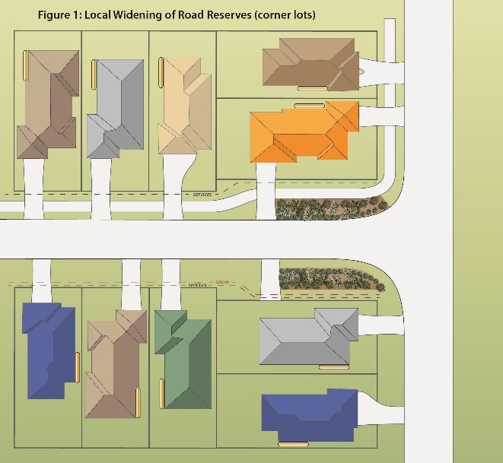  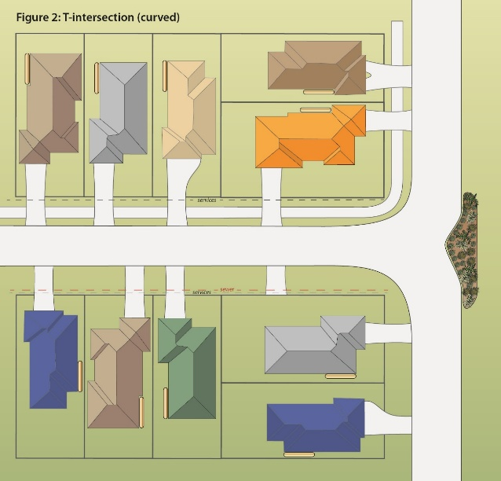  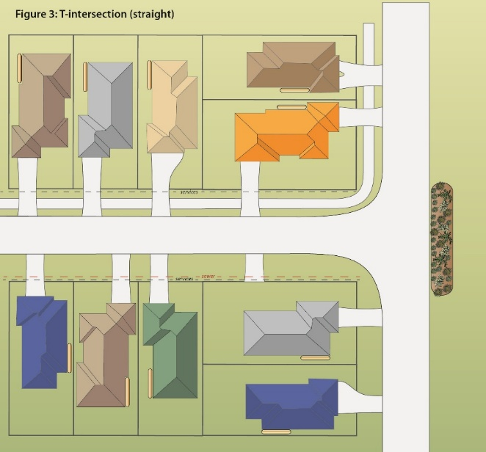  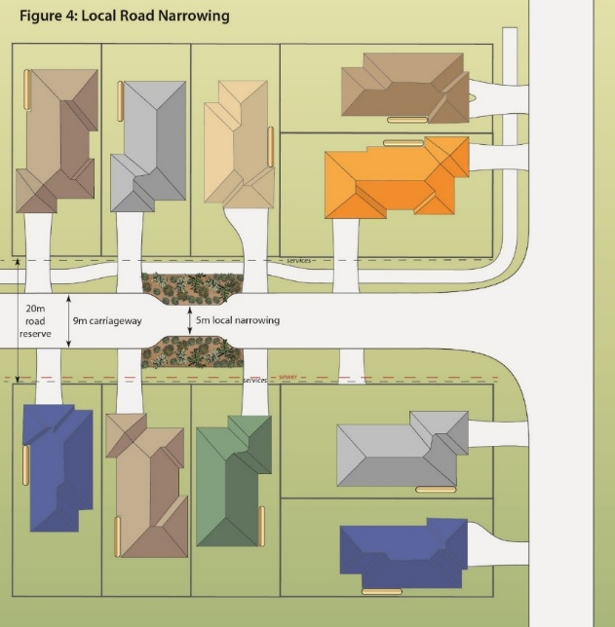  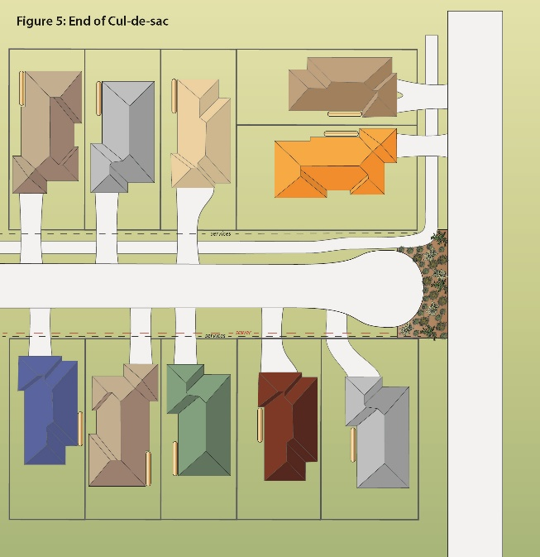
Section 3.4.9 and Section 3.4.10 | New guidance and clarification regarding collocation with detention basins (Section 3.4.9) and flood immunity requirements (Section 3.4.10).  Comment: Changes generally supported, no further comment. | N/A
Section 3.5.3.2 | New advice regarding sediment capture in streetscape bioretention  Comment: Changes generally supported, no further comment. | N/A
Section 3.5.3.3 | Further guidance on the use of energy dissipation and alignment of sediment forebays  Comment: Changes generally supported, no further comment. | N/A
Section 3.5.3.4 | Additional guidance on designing inlet ponds for large bioretention systems  Comment: Changes generally supported, no further comment. | N/A
Section 3.5.6 | New information on how to manage baseflows into bioretention  Comment: Changes generally supported, no further comment. | N/A
Section 3.5.7 | Enhanced guidance on flow distribution  Comment: Changes supported, no further comment. | N/A
Section 3.6.1.1 | Reduced requirements for underdrainage cleanout points  Comment: Stormwater Queensland believes that the statement about damaged cleanout pipes is greatly exaggerated, especially where they are protected by concrete at the riser access points.  Similarly, the statement about flushing pipes from only the outlet pit is not relevant to many basins, especially on larger basins where long collector pipes accept flows from dozens of slotted pipes and cleaning each slotted pipe from the pit alone is not feasible. In most cases, flushing requires work from both ends to be effective.  Moreover, in our experience, bioretention systems, including those correctly constructed and using the best media on the market can significantly block with fine sediment (mostly likely from the media itself) and require flush out. As an example, the photos below show a correctly constructed, lined system, with filter media from of SEQ’s best suppliers and which only experienced direct rainfall (no stormwater) prior to inspection. In this system, all pipes (slotted and collector) were 60-100% blocked. On most pipes, the camera would not pass more than 1-2 meters into the pipe due to complete blockage. This can clearly happen on a system where everything goes right.  While such blockage may or may not be widespread, removing the inspection rises prevents the asset manager from effectively addressing it when it does occur. Suffice to say that the recommendation to remove the inspection rises is not supported.  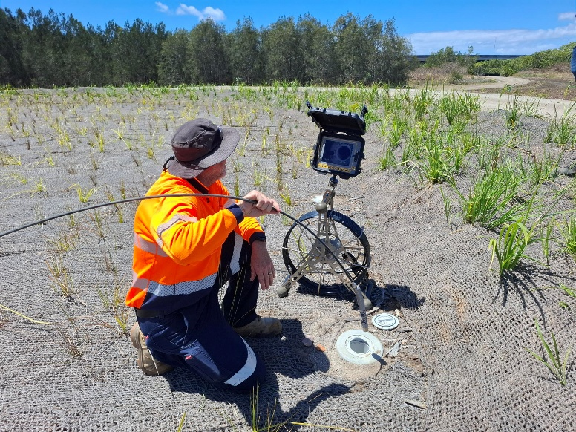  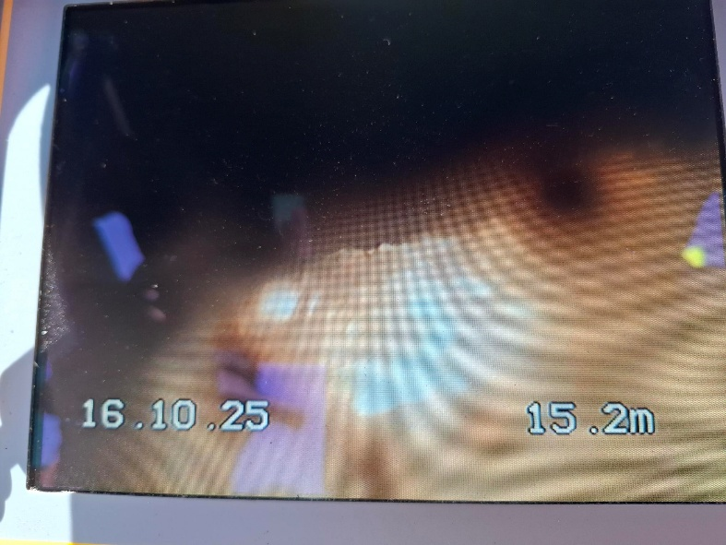  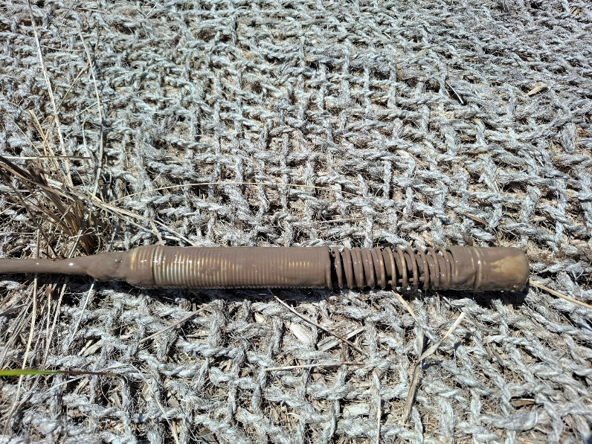 | Stormwater Queensland strongly recommends that the inspection risers be retained.  It is also recommended that the guidelines provide specific requirements for inspection (and clean out on an as-needs) of all biobasins following construction including slotted drainage pipes and collector pipes. This should be made common-practice and if there is widespread evidence at a later date that the need for clean-outs is the exception rather that the rule, only then should the revision of guideline to exclude inspection risers be considered.
Section 3.6.1.4 | Alterations to pit and riser configurations for saturated zone systems  Comment: Changes generally supported, no further comment. | N/A
Section 3.6.1.5 | Guidance on the use of temporary upstands during plant establishment  Comment: The recommendation to include the temporary upstand is supported however the suggested approach to have it as high as 150mm below surface level and gradually cut it down over 6-12 months is not supported.  Filter media is not supposed be saturated for such prolonged periods otherwise it begins to leach nutrients. Additionally, plants can draw on water well below their root zones using capillary action obviating the need to keep the water so high for so long. | It is recommended that the temporary upstand be retained however, it should allow for no more that say ¼ of filter media depth to be saturated.  The length of saturation is up for debate but could be at full height for first 3 months after planting and then halved for second subsequent 3 months and then drawn down to the top of the transition layer for the subsequent 6 months.  Some aspect of the pipe should be retained at all times rather than complete removal even if it’s only the final 100mm, allowing a connection for asset manages to re-instate the riser during drought for example at little cost.
Section 3.6.2.1 | Change to recommended raised dome grates rather than raised flat grates  Comment: Changes generally supported, no further comment. | N/A
Section 3.7 | Expanded vegetation design section with much greater focus on planting to create resilient and low-maintenance ecosystems. The use of trees is now the default in all bioretention unless there is an overriding reason not to include them  Comment: Changes generally supported, no further comment. | N/A
Throughout | Several figures are difficult to read. While this is the case for many figures, please consider the following in particular: Figure 14, Figure 17, Figure 31, Figure 55, Figure 56, Figure 57, Figure 79 & Figure 80. | Suggest providing high resolution versions of these figures and increase the size of some of the more detailed cross sections (Figure 14, Figure 79, Figure 80).

